
Savitribai Phule Pune University
INTERDISCIPLINARY SCHOOL OF SCIENTIFIC COMPUTING
Mid Sem Exam - II
Course No. : SC 104
Title : Mathematics for Scientific Computing

Date : 07 / 10 / 2015 Marks : 30
Time : 11:00 am to 12:30pm

Q.1 Attempt any five. ( 2 marks each)
(i) Evaluate the integral 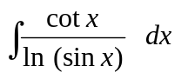
(ii) Evaluate the integral 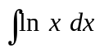

(iii) Evaluate the integral 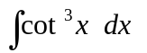

(iv) Calculate the area bounded by the parabola 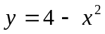 and the 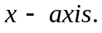

(v) Find the length of the curve 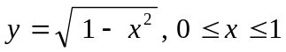

(vi) Find 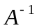if 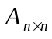is the lower triangular matrix given by
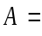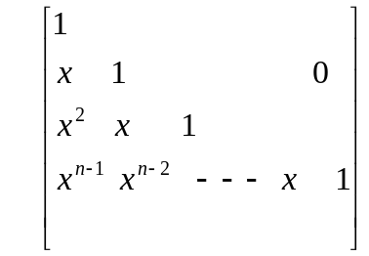
(vii) Find ( do not calculate ) the eigenvalues of and 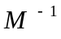
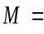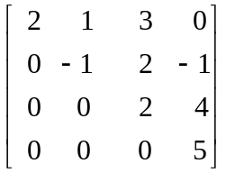
(viii) Calculate the determinant of matrix 
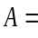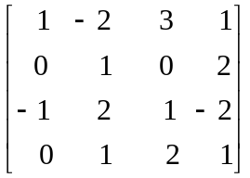

Q.2 Attempt any four. ( 5 marks each)

- (i) Evaluate the integral 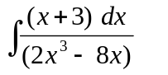 (3)
(ii) Find rank of the matrix (2)

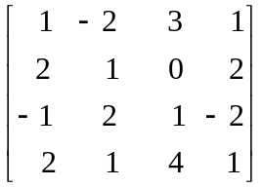

- (i) Evaluate the integral 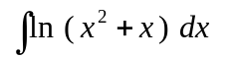 (3)
(ii) Evaluate the integral 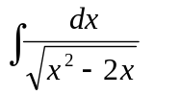 (2)
- Consider the following matrix.

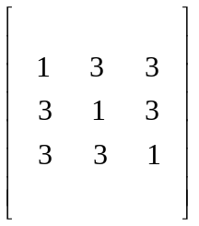
(i)Find the eigen values of matrix (3)

(II)Find any one eigenvector of (1)

(iii) Find 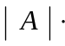( Do not expand, just state.) (1)
- The region bounded by the curve 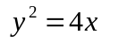and the line 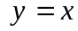 is rotated around
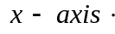 Find the volume of the solid generated.

- Consider the curve
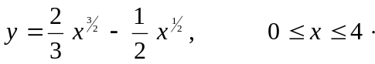
Find the length of this curve and the surface area of the solid of revolution when the
curve is rotated around 



